TASK 8
CRUD operations in Document databases

AIM:
To Perform Mongoose using NPM design on MongoDB designing document database and performing CRUD operations like creating, inserting, querying, finding, removing operations
STEPS:
Step 1: Install Mongo db using following link
https://www.mongodb.com/try/download/community
Step 2: install Mongosh using the below link
https://www.mongodb.com/docs/mongodb-shell/#download-and-install-mongosh
Step 3: To add the MongoDB Shell binary's location to your PATH environment variable:
3.1 Open the Control Panel.
3.2 In the System and Security category, click System.
3,3 Click Advanced system settings. The System Properties modal displays.
3.4 Click Environment Variables.
3.5 In the System variables section, select path and click Edit. The Edit environment
variable modal displays.
3.6 Click New and add the filepath to your mongosh binary.
3.7 Click OK to confirm your changes. On each other modal, click OK to confirm
your changes.
Step 4: To confirm that your PATH environment variable is correctly configured to find
mongosh, open a command prompt and enter the mongosh --help command. If your
PATH is configured correctly, a list of valid commands displays.

Step 5: Open mongo shell 4.0 from c:\programfiles\mongoDB\server\bin\mongod.exe

Step 6: Type the CRUD(CREATE READ UPDATE DELETE) COMMANDS GIVEN IN
TEXT FILE.

CRUD OPERATIONS:

db.createCollection("CricketBorad")
{ "ok" : 1 }
> db.CricketBoard.insertOne({BoardID: "BID01", Name:"Chennai Cricket Board", Address:"Chennai",Phone:9988776699});
{
"acknowledged" : true,
"insertedId" : ObjectId("651cf1726ebbfe7993adf909")
}
db.mylab.find({BoardID:"BID01"})
{ "_id" : ObjectId("651cf1726ebbfe7993adf909"), "BoardID" : "BID01", "Name" : "Chennai Cricket Board", "Address" : "Chennai", "Phone" : 9988776699 }

db.CricketBoard.insertMany([{BoardID:"BID02",Name:"Tiruvallur Cricket Board",Address:"Chennai",Phone:9977886699},{BoardID:"BID03",Name:"Viluppuram Cricket Board",Address:"Viluppuram",Phone:9966886699},{BoardID:"BID04",Name:"Trichy Cricket Board",Address:"Trichy",Phone:9955886699},{BoardID:"BID05",Name:"Madurai Cricket Board",Address:"Madurai",Phone:9944886699}]);

{
"acknowledged" : true,
"insertedIds" : [
ObjectId("651ceee36ebbfe7993adf904"),
ObjectId("651ceee36ebbfe7993adf905"),
ObjectId("651ceee36ebbfe7993adf906"),
ObjectId("651ceee36ebbfe7993adf907")
]
}

db.CricketBoard.find()
{ "_id" : ObjectId("651ceee36ebbfe7993adf904"), "BoardID" : "BID02", "Name" : "Tiruvallur Cricket Board", "Address" : "Chennai", "Phone" : 9977886699 }
{ "_id" : ObjectId("651ceee36ebbfe7993adf905"), "BoardID" : "BID03", "Name" : "Viluppuram Cricket Board", "Address" : "Viluppuram", "Phone" : 9966886699 }
{ "_id" : ObjectId("651ceee36ebbfe7993adf906"), "BoardID" : "BID04", "Name" : "Trichy Cricket Board", "Address" : "Trichy", "Phone" : 9955886699 }
{ "_id" : ObjectId("651ceee36ebbfe7993adf907"), "BoardID" : "BID05", "Name" : "Madurai Cricket Board", "Address" : "Madurai", "Phone" : 9944886699 }
{ "_id" : ObjectId("651cf1726ebbfe7993adf909"), "BoardID" : "BID01", "Name" : "Chennai Cricket Board", "Address" : "Chennai", "Phone" : 9988776699 }

db.CricketBoard.find().pretty()
{
"_id" : ObjectId("651ceee36ebbfe7993adf904"),
"BoardID" : "BID02",
"Name" : "Tiruvallur Cricket Board",
"Address" : "Chennai",
"Phone" : 9977886699
}
{
"_id" : ObjectId("651ceee36ebbfe7993adf905"),
"BoardID" : "BID03",
"Name" : "Viluppuram Cricket Board",
"Address" : "Viluppuram",
"Phone" : 9966886699
}
{
"_id" : ObjectId("651ceee36ebbfe7993adf906"),
"BoardID" : "BID04",
"Name" : "Trichy Cricket Board",
"Address" : "Trichy",
"Phone" : 9955886699
}
{
"_id" : ObjectId("651ceee36ebbfe7993adf907"),
"BoardID" : "BID05",
"Name" : "Madurai Cricket Board",
"Address" : "Madurai",
"Phone" : 9944886699
}
{
"_id" : ObjectId("651cf1726ebbfe7993adf909"),
"BoardID" : "BID01",
"Name" : "Chennai Cricket Board",
"Address" : "Chennai",
"Phone" : 9988776699
}

db.CricketBoard.deleteOne({BoardID:"BID03"})
{ "acknowledged" : true, "deletedCount" : 1 }
db.CricketBoard.find().pretty()
{
"_id" : ObjectId("651ceee36ebbfe7993adf904"),
"BoardID" : "BID02",
"Name" : "Tiruvallur Cricket Board",
"Address" : "Chennai",
"Phone" : 9977886699
}
{
"_id" : ObjectId("651ceee36ebbfe7993adf906"),
"BoardID" : "BID04",
"Name" : "Trichy Cricket Board",
"Address" : "Trichy",
"Phone" : 9955886699
}
{
"_id" : ObjectId("651ceee36ebbfe7993adf907"),
"BoardID" : "BID05",
"Name" : "Madurai Cricket Board",
"Address" : "Madurai",
"Phone" : 9944886699
}
{
"_id" : ObjectId("651cf1726ebbfe7993adf909"),
"BoardID" : "BID01",
"Name" : "Chennai Cricket Board",
"Address" : "Chennai",
"Phone" : 9988776699
}
Result:
Thus CRUD using NPM design on MongoDB designing document database and performing CRUD operations like creating, inserting, querying, finding, removing operations are performed.
TASK 9
CRUD operations in Graph databases

AIM:
To perform CRUD operations like creating, inserting, querying, finding, deleting operations on graph spaces.
The steps to get started with Neo4j's Aura Graph Database:
Step1: Copy and paste the following link into your web browser: https://neo4j.com/cloud/platform/aura-graph-database/?ref=docs-get-started-dropdown
Step2: Click on "Start Free."
Step3: Choose the option to "Continue with Google."
Step4: Click the "Open" button.
Step5: After clicking "Open," a text file will be automatically downloaded. This file contains your user ID and password details.
Step6: Copy the password from the downloaded text file and paste it where required.
Step7: Close the "Get started with Neo4j with beginner guides" if it's open.
Sep8: You're now ready to begin practicing with the Graph Database.

Create Node with Properties
Properties are the key-value pairs using which a node stores data. Create a node with properties using the CREATE clause and need to specify these properties separated by commas within the flower braces “{ }”.
Syntax
CREATE (node:label { key1: value, key2: value, . . . . . . . . . }) return node

To verify the creation of the node, type and execute the following query in the dollar prompt.
Syntax:
MATCH (n) RETURN n
Creating Relationships
To create a relationship using the CREATE clause and specify relationship within the square braces “[ ]” depending on the direction of the relationship it is placed between hyphen “ - ” and arrow “ → ” as shown in the following syntax.
Syntax:
CREATE (node1)-[:RelationshipType]->(node2)
Syntax:
MATCH (a:LabeofNode1), (b:LabeofNode2)
WHERE a.name = "nameofnode1" AND b.name = " nameofnode2"
CREATE (a)-[: Relation]->(b) RETURN a,b

Deleting a Particular Node
To delete a particular node and need to specify the details of the node in the place of “n” in the above query.
Syntax:
MATCH (node:label {properties . . . . . . . . . . }) DELETE node

Create a graph database for student course registration, create student and dept node and insert values of properties.
Create a CrickerBoard Node:
create(cb:CricketBoard{BoardID:'BID01',Name:'Chennai Cricket Board', Address:'Chennai', Phone:9988776699}) return cb
Create Team Nodes:
create(t1:Team{teamID:'CCB01',BoardID:'BID01',name:'ABS EXPRESS', Coach:'G.D.RAMESH', Captain:'SAMPATH KUMAR'}) return t1
create(t2:Team{teamID:'CCB02',BoardID:'BID01',name:'AVG EXPRESS',Coach: 'T.KARTHIKH', Captain:'Y.JOHN'}) return t2
Create Player Nodes:
create(p1:Player{PlayerID:'1',TeamID:'CCB01',Name:'Raj',Age:23,DateofBirth:'29-JUN-1996', PlayingRole:'Bowler',email:'rajn@gmail.com'}) return p1
create(p2:Player{PlayerID:'33',TeamID:'CCB01',Name:'Anand',Age:23,DateofBirth:'02-JAN-1999', PlayingRole:'Batsman',email:'balajid@gmail.comm'}) return p2
create(p3:Player{PlayerID:'65',TeamID:'CCB02',Name:'Suresh',Age:27,DateofBirth:'02-JUN-1996', PlayingRole:'Batsman',email:'sureshd@gmail.comm'}) return p3
create(p4:Player{PlayerID:'75',TeamID:'CCB02',Name:'Rohit',Age:33,DateofBirth:'02-JUN-1991', PlayingRole:'Batsman',email:'srohit@gmail.comm'}) return p4
Creating Relationship among CricketBoard and Teams:
match(cb:CricketBoard{BoardID:'BID01'}),(t1:Team{teamID:'CCB01'}) create(cb)-[r:has]->(t1) return cb,r,t1
match(cb:CricketBoard{BoardID:'BID01'}),(t2:Team{teamID:'CCB02'}) create(cb)-[r:has]->(t2) return cb,r,t2
Creating Relationship among Players and Teams:
match(p1:Player{PlayerID:'1'}),(t1:Team{teamID:'CCB01'}) create(p1)-[r1:playfor]->(t1) return p1,r1,t1
match(p2:Player{PlayerID:'33'}),(t1:Team{teamID:'CCB01'}) create(p2)-[r2:playfor]->(t1) return p2,r2,t1
match(p3:Player{PlayerID:'65'}),(t2:Team{teamID:'CCB02'}) create(p3)-[r3:playfor]->(t2) return p3,r3,t2
match(p4:Player{PlayerID:'75'}),(t2:Team{teamID:'CCB02'}) create(p3)-[r4:playfor]->(t2) return p4,r4,t2
Display All nodes: match(n) return n
Output:
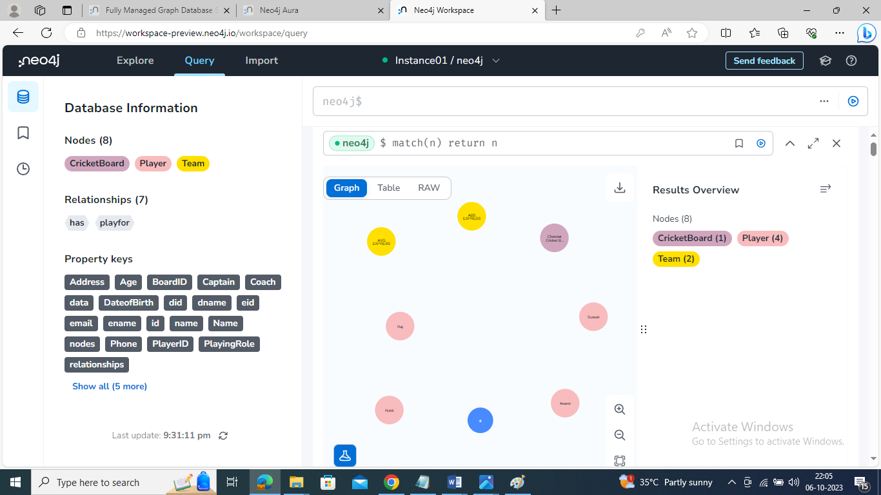

OUTPUT:
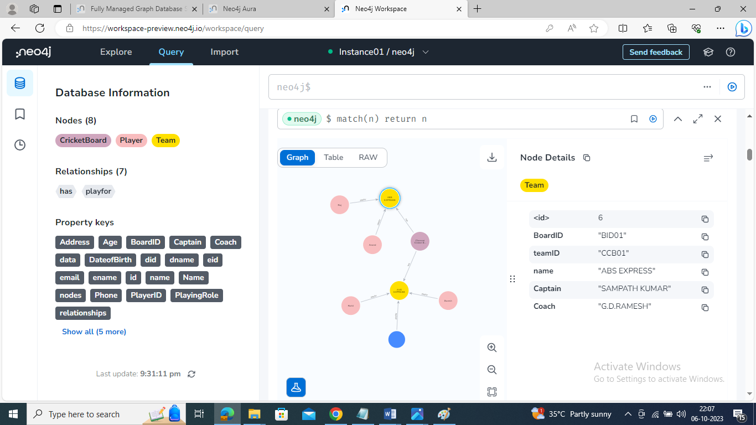

Retrieve particular player details:
match(p:Player{PlayerID:'33'}) return p

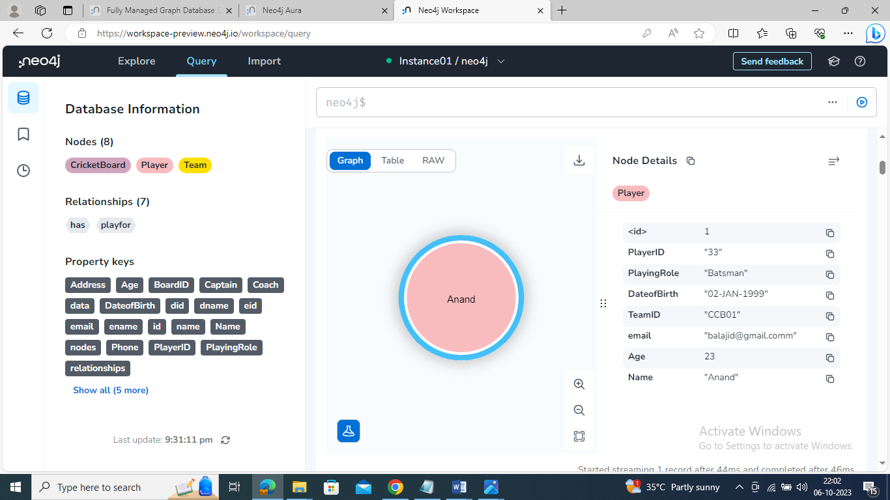

Update particular player details:
match(p:Player{PlayerID:'1'}) set p.age=27 return p
Output:
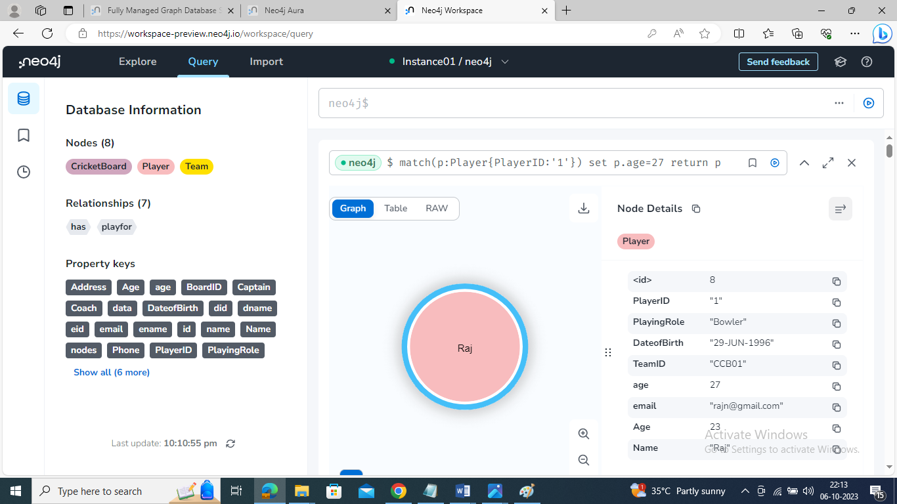

Delete particular player from the team:
match(p:Player{PlayerID:'33'}) delete p
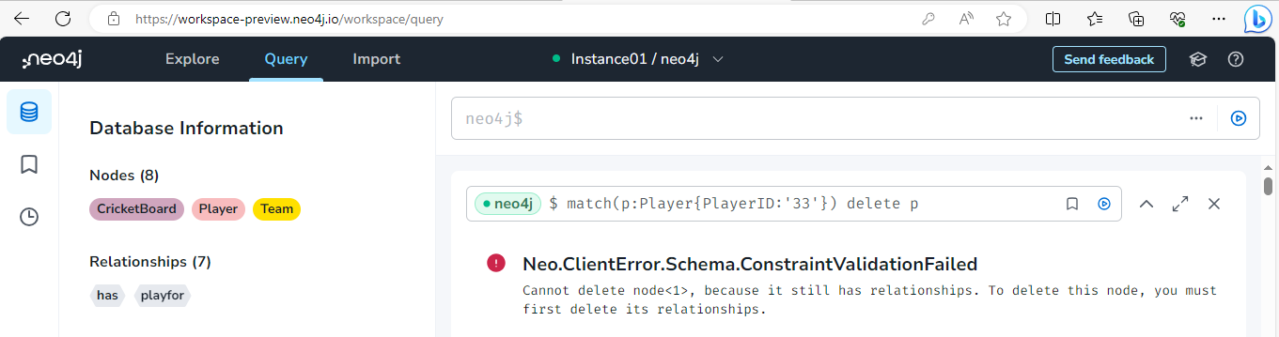

Result:
Thus the CRUD operations like creating, inserting, querying, finding, deleting operations on graph spaces were executed successfully.

